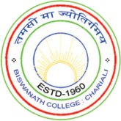

BISWANATH COLLEGE
Academic Calendar for the Academic Session 2020 - 21 & 2021 - 22
for all Undergraduate (UG) & Postgraduate (PG) Courses
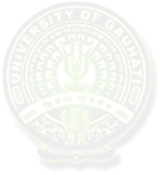(In accordance with the academic calendar provided by Gauhati University Vide GU Notification GU/Acad/2020/6607 dated 21-Dec-2020)

Date(s) | Event / Activity / Target
21-Sep-2020 | Commencement of UG (Undergraduate) 1st, 3rd, 5th Semester (Online & Oﬄine) classes
01-Nov-2020 | Commencement of PG (Postgraduate) 3rd Semester classes
24-Dec-2020 | Admission to the PG 1st Semester to be completed by this date
26-Dec-2020 | Commencement of PG 1st Semester classes
10 — 17-Jan-2021  (8 days) | Winter Break
1 – 6 Feb - 2021 | Sessional Examinations to be Conducted
15-Mar-2021 | Commencement of UG 1st, 3rd, and 5th Semester and PG 3rd Semester examinations
01-Apr-2021 | Commencement of PG 1st Semester examinations
19-Apr-2021 | Commencement of UG 2nd, 4th, and 6th Semester and PG 2nd and 4th Semester classes
10 — 31-Jul-2021  (22 days) | Summer Break
05-Aug-2021 | Commencement of UG 2nd, 4th and 6th Semester and PG 2nd and 4th Semester examinations
06-Sep-2021 | Commencement of UG 3rd, 5th and PG 3rd Semester classes
07-Sep-2021 | College Foundation Day
01-Oct-2021 | Commencement of PG 1st Semester classes
After the admission process | Commencement of UG 1st Semester classes

** In view of the current pandemic situation, to adjust the academic sessions some changes may be needed depending on the situation which will be notified in due course of time.

